Request:

RF SKU Storage type and ABC category lookup

ASR 6095:

## Email infor:

**From:** Lim, Winston Wee Sin   
**Sent:** Friday, 29 April, 2016 2:58 PM  
**To:** Chan, Pei-Fong  
**Cc:** Jack, Fong  
**Subject:** RE: BD RDC SKU-master lookup module

Hi Pei Fong,

1.

|  |
| --- |
| **Description**  **/Storage condition** |
| NAC |
| Minus 20 Deg |
| Minus 80 Deg |
| AC |
| Posiflush |
| AC |

2. can put 8 characters.

Going to have AA, A, B, C, D

3. RF Screen:

- can we have colour code for different storage types?

- can we have red background for Cat AA only?

Best Regards

Winston Lim (Mr)

Senior Industrial Engineer

Contract Logistics/ SCM, Management

Schenker Singapore (Pte) Ltd

17 Changi South Street 2 Singapore 486129

DID +65 6549 1143 Fax +65 6245 5300

Mobile +65 9233 7837

**From:** Lim, Winston Wee Sin   
**Sent:** Wednesday, 27 April, 2016 2:32 PM  
**To:** Chan, Pei-Fong  
**Cc:** Low, Dennis; Jack, Fong; Tan, khang-hwee; Ng, Poh Sing  
**Subject:** BD RDC SKU-master lookup module

Hello Pei Fong,

As spoken, BD RDC is requesting for a RF module for below purpose

Upon inbound:

Storekeeper scans SKU (Material number) with WMS RF

WMS returns 2 results after cross-checking with WMS SKU Master

* Storage Condition
  + -80 Deg
  + -20 Deg
  + 2-8 Deg
  + AC storage
  + NAC storage
* ABC Category of SKU

No WMS transactions are required. Just a simple lookup.

Ops will maintain all information in the WMS SKU master.

Please provide the date when this module can be ready.

Best Regards

Winston Lim (Mr)

Senior Industrial Engineer

Contract Logistics/ SCM, Management

Schenker Singapore (Pte) Ltd

17 Changi South Street 2 Singapore 486129

DID +65 6549 1143 Fax +65 6245 5300

Mobile +65 9233 7837

Current Mapping:

Location Storage type mapped to SKU Storage type

|  |  |  |
| --- | --- | --- |
| Location Storage type | SKU Storage type | Storage condition |
| 400 | 11A | OK |
| 401 | 11B | 2 different storage types for freezer. Minus 20 deg, minus 80 deg.  Need additional storageType.  Suggest  “11B-20” for minus 20 deg  “11B-80” for minus 80 deg |
| 402 | 11C | OK |
| 403 | 11D | OK |
| 404 | 11E | OK |

## NEW CHANGE REQUEST:

New Mapping:

SAP constraints: SAP Storage type 401 not able to split to storage condition.

1. Mapped storage type between SKU and Location master.
   1. SAP Storage type - NO CHANGE

|  |  |
| --- | --- |
| **SAP Stor. Type** | **Description** |
| 400 | Ambient |
| 401 | Freezer |
| 402 | AirCon |
| 403 | Reefer |
| 404 | Posiflush |

* 1. SKU Storage type

|  |  |  |
| --- | --- | --- |
| **SKU Storage type**  **SKU.** **SUSR4** | **Description**  **Storage condition** | **Color** |
| 11A | NAC |  |
| 11B-20 | Minus 20 Deg | Blue |
| 11B-80 | Minus 80 Deg | Red |
| 11C | AC |  |
| 11D | Reefer |  |
| 11E | Posiflush |  |

* 1. ABC Category= AA, A, B, C and D

Field: SKU.ABC

1. RF SKU lookup

SKU:

Storage Type:

Category:

Clear

RF Screen request:

1. To display different color code for different storage types.
2. Please show “**Cat AA**“ as separate from the storage conditions. With red background too. All other categories do not need special background.

## Actual Changes in WMS:

Master Setup:

### System code setup

* 1. CODE = SKU Storage type, List Name = SKSTORTYPE

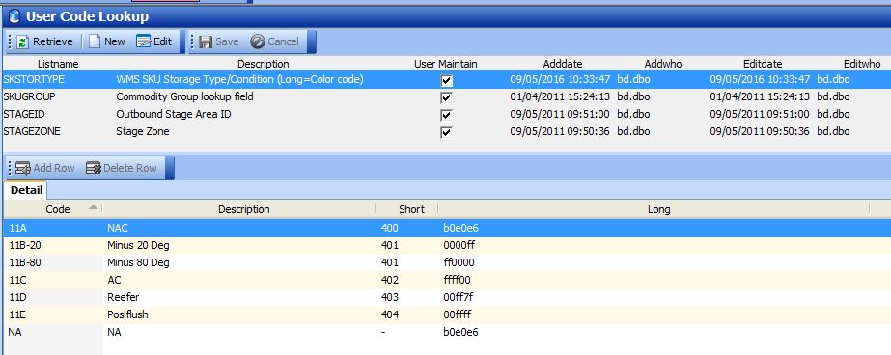

* 1. CODE = ABC, List Name = ABC

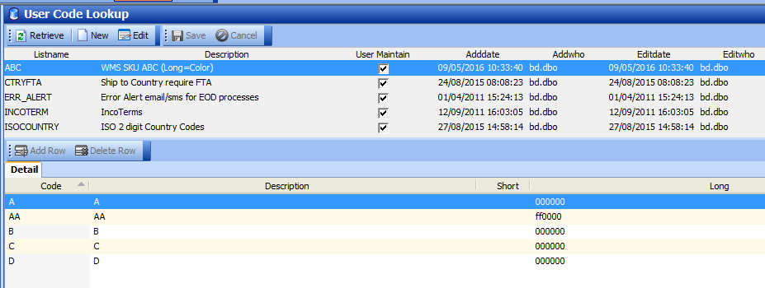

### SKU Setup Storage Condition in both SKU and Location Master.

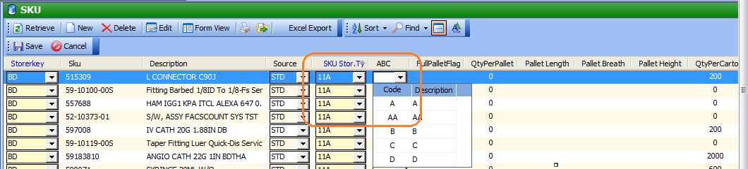

### LOCATION Master – new WMS Storage type field.

New field Loc.LocationHandling = Storage condition

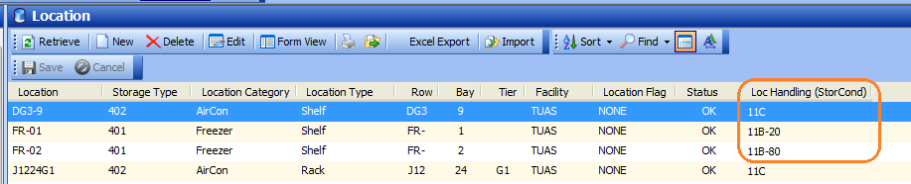

### Report – Storage type mapping report.

Changes to cater the new mapping between SKU and Location master

Report: List of inventory snapshot imported from Customer system, perform location storage type mapping vs SKU Storage type mapping.

Status will be displayed on column: “Storage Status” - “OK” if matched, “Failed” if not matched.

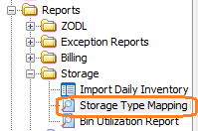

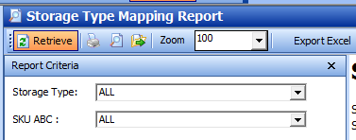

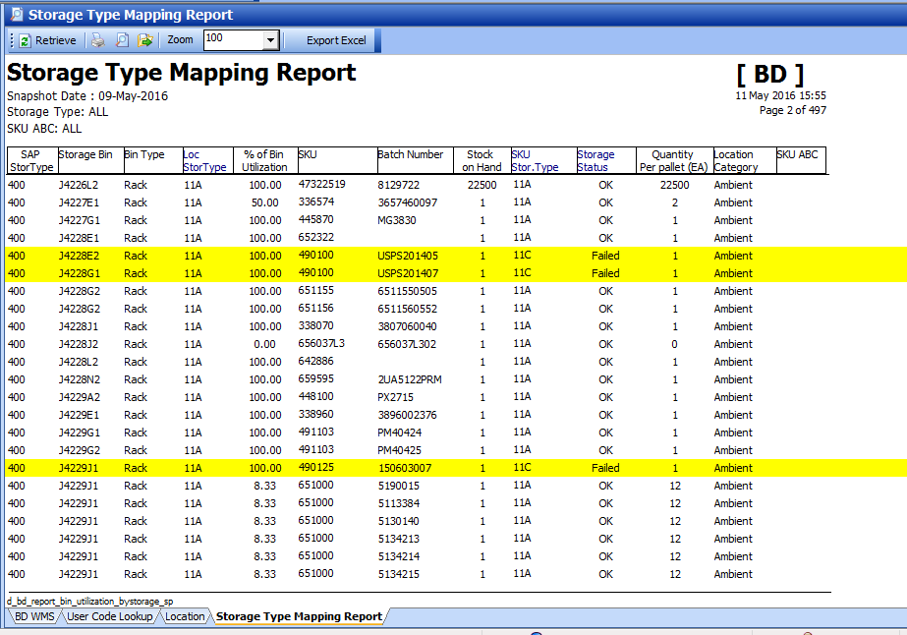

## RF SKU lookup

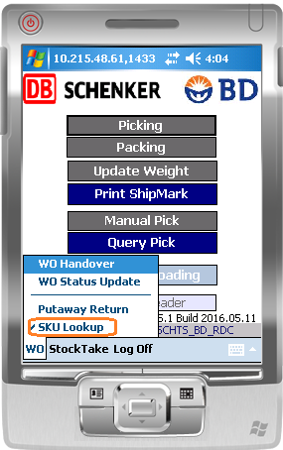

|  |  |  |
| --- | --- | --- |
| **Storage cond. code** | **Storage condition description** | **RF screen** |
| 11A | NAC |  |
| 11B-20 | Minus 20 Deg | SKU -20 degree and Cat AA    SKU -20 degree and cat A: |
| 11B-80 | Minus 80 Deg |  |
| 11C | AC |  |
| 11D | Reefer |  |
| 11E | Posiflush |  |

# Deployment:

Library: bd_outbound.pbd bdto.pbd, bd_report.pbd

SQL: rpt_SCH_BD_REPORT_Storage_Type_Mapping.sql, 00_Insert_SKUStorageType_ABC.sql

*<End of Document>*